Morehead State University
Adjustable Allen Wrench
ITCD 615 Design Brief – Fall 2012
Bradley Bryan, Travis Fisher, and Samantha Hamilton
11/28/2012

The Allen wrench is a very simple tool designed to tighten and loosen hex head nuts. The tool being discussed in this article is called the All-In-One hex wrench and is designed maintain the basic function of the Allen wrench while improving on the user ability. Instead of having a bulky kit of L-shaped Allen wrenches, one could replace them with the All-In-One hex wrench which would increase organization, ease of use, and the time spent changing tools would be significantly reduced.

Contents
Company Profile 3
Specializations 3
Profile of People Involved 3
Company Name 3
Problem Statement 3
Problem Description and Background 3
Constraints and Assumptions 3
Project Objectives 3
Goals 3
Desired Outcomes 3
Due Dates 3
Solution Analysis 3
Planned Solutions 4
Concept Screening & Scoring Tables 4
Concept Combination Tables 4
Sketches 4
Project Tolerances 4
Project Scope and Exclusions 4
Critical Success Factors 4
Interfaces 4
Synopsis 4
Evaluation 4
Conclusion/Summary 4
Signature Page 4
References 5
Appendices 5

Company Profile
An Allen wrench or Allen key is a familiar brand name for a hex key or hex head wrench, a tool that drives a screw or bolt called a “socket head cap screw.” This type of screw, with a recessed hexagonal head is common in all kinds of different products. The “Allen screw” name for the socket head cap screw and “Allen key” for the wrench originate from the products of the Allen Manufacturing Company of Hartford, Connecticut. According to Bates, it is widely reported that the company trademarked the name “Allen wrench or key” for its range of hex wrenches in 1943. (eHow, 2012)
The benefit to using an Allen key as opposed to the conventional six-sided nut or bolt is that the hex head is less susceptible to wear and tear because the hexagonal socket is indented into the nut rather than around the outside of it. This feature not only increases the life span of the nut, but it also increases its rigidity and functionality.
The hex wrench is designed to be used with a driver that is connected to a long L-shaped tool as seen in Figure 1. If the shorter end is used torque is maximized and if the longer end is used leverage is maximized.
Figure 1: Example of a Standard Allen Wrench (Foresman, 2008)
The functionality of the hex wrench is stable, so the basic design is secured. Quality innovation for this tool lies in its design for ease of use, multi-function, and quick and easy tool change. The product design being presented here is called the “All-In-One” Hex Wrench.

Specializations
- A hex wrench that can adjust to multiple sizes of hex nuts quickly and easily.
- A functionally sound product that adheres to the general needs of any handyman.
- Denotes the need to own a bulky set of Allen wrenches and instead offers a much more convenient “All-In-One” tool.

Profile of People Involved
The team behind the scenes of this product development consisted of the following three members and their duties included:

Samantha Boone (Group Leader): Problem description and background, constraints and assumptions, critical success factors, interfaces, project objectives, due dates, and concept design.

Bradley Bryan: Compiled product goals, tolerances, project scope and exclusions, and the concept design.
Travis Fisher: Company profile, product specializations, mission statement, and the concept design.

Solution Analysis

Company Name
The “All-In-One” Hex Wrench

Problem Statement

Problem Description and Background
There are seemingly millions of tools available in our world today but the selection of Allen wrenches is pretty basic. There are few, if any, adjustable Allen wrenches available in the market today. There is a need for a new design that will allow for a user to carry a set of wrenches on his/her person, or store them, with the space taken up being minimal. The proposed design will allow someone to have access to a full metric or English set of Allen wrenches all in one piece. The set will properly adjust to the necessary size with little effort from the user for quick and easy use. With the All-In-One tool, the time spent with trial and error of fitting different sizes to a hex bolt will no longer exist – the tool will do the work for the user.

Constraints and Assumptions
The assumptions and constraints for this product are as follows:
- Hand-held device
- Early models are limited to use for small projects (such as electronics, some home and office use, etc) where the hex bolts the product will be used on are not rusted and/or will required minimal forces to extract or tighten the bolts. Later models will be built and tested for more durability.
- Manual operation necessary
- More compact than competitor products
- The product will be used by consumers properly as instructed
- Durable product – on par with, or better than, competitors

Overall the constraints and assumptions of this product are that consumers will use the product as instructed and the product will maintain the advertised durability and strength. The product will be a functional Allen wrench that will compete with the standard set used so widely today. The adjustable set will be compact and portable that will help set it apart from the standard sets in existence.

Project Objectives
The objectives of this project include:
- Brainstorming multiple design possibilities for this product and then proceeding to the concept screening and scoring tables to assist in determining the best design for the product.
- To set and exceed the standards of durability set for the product.
- To sell the product for about the same, if not less than, competitor prices. The range would ideally be between $15 and $30.
- To finalize the product design and submit the final plans on or before the December 7th deadline. Advertising of the product could begin before the holidays.
- Product would begin production in January 2013.
- Work up to getting the company to being responsible for a minimum of 12% of the handheld tool market by the beginning of 2014.
- Expand on the adjustable wrench product and produce enhanced versions for more variety of uses further down the road.
- (Risk and benefit, performance goals, scope….)

Goals

Desired Outcomes
- Design a variety of the best concept sketch by hand of an adjustable Allen Wrench
- Evaluate the concept sketches and decide on the best concept that would work for manufacturing
- Divide each part of the concept design among pairs to draw on the CAD software
- Assemble parts together on the CAD software and provide FEA analysis of the product outcome.
- Provide Sheets of dimensions to make they meet the standard tolerances of the Allen Wrench.
- Set up for Prototyping of the Design from The CAD software
- Show Project Submission of the final set up of the Model.

Due Dates
Figure 2: Project Timeline
(Above is a possible Gantt chart…for now it is a space-filler).

Solution Analysis
This section covers the design variations that were discussed between team members. Some designs are more practical and durable than others, and these were two of the factors that went into deciding which design would be moved on to development.

Planned Solutions
Four preliminary designs were brainstormed in comparison to the reference product of the standard individual set of L-shaped Allen wrenches. Each of the brainstormed designs offer an adjustable feature to cut down on time needed for proper sizing and use. These designs are as follows:
- Design A: The most simple design concept. Pressure operated as the user applies pressure on the wrench handle and a stepped off pin pushes down on telescopic layered Allen wrenches to fit the properly sized wrench in the designated hex bolt head. This is a simple tool that will allow the proper fitting quickly.
- Design B: Based off the design of a multi-ink cartridge ink pen, this concept uses a sliding contact and the tension of a spring to slide the telescopic Allen wrench sizes into the hex bolt until the correct size and everything smaller fits within the bolt head. The notches on the slider lock the correct size into place. The extensions are released by pressing the button on the top of the shaft within the loop of the handle. This compresses the spring and tilts the slider slightly to release the notches from locked position.
- Design C: Similar to some existing designs for a screwdriver set, this concept stores the extra Allen wrench sizes within the handle and are locked into place until a rotating collar on the shaft is turned and the selected size Allen wrench falls from the handle down a tapered tunnel to the head of the tool and is then locked into place with the flick of a switch.
- Design D: This concept uses bits and pieces of the other designs as well as new concepts. The main shaft of the tool uses the telescopic extending Allen wrenches (similar to what is used with Designs A and B), but these are released through the lifting of a collar to release the different sized Allen wrenches and the necessary size will fit the bolt while the rest will recess back up into the tool when they do not extend as far as the rest. Releasing the collar will lock the wrenches into position. Larger wrench sizes are stationary in the two arms of the handle for larger projects. This wrench set also has the makeup of a socket wrench feature as well. There is a switch on the handle to select the direction of rotation for the tool to assist in tightening or loosening to promote constant movement rather than having to completely twist the tool in full rotations.
- Design E: This design has two arms that swing out to create the handle as well as are storage for the extra wrench bits. These bits are held into the handles by small magnets and nested holders for the specific sizes. There is an opening on the base of the tool for the wrenches to be inserted for use. Since different sizes are going to be used the holder for the bits must be adjustable to hold each bit tightly. This adjustment is done through a rotating collar on the tool which will adjust the tightness around the tool. This adjustment is also what is used to release the bit.
- Reference: Standard Allen wrench set of the "L-shaped" wrenches that all slide into a plastic holder.

The brainstorming sketches of these designs follow.

Sketches
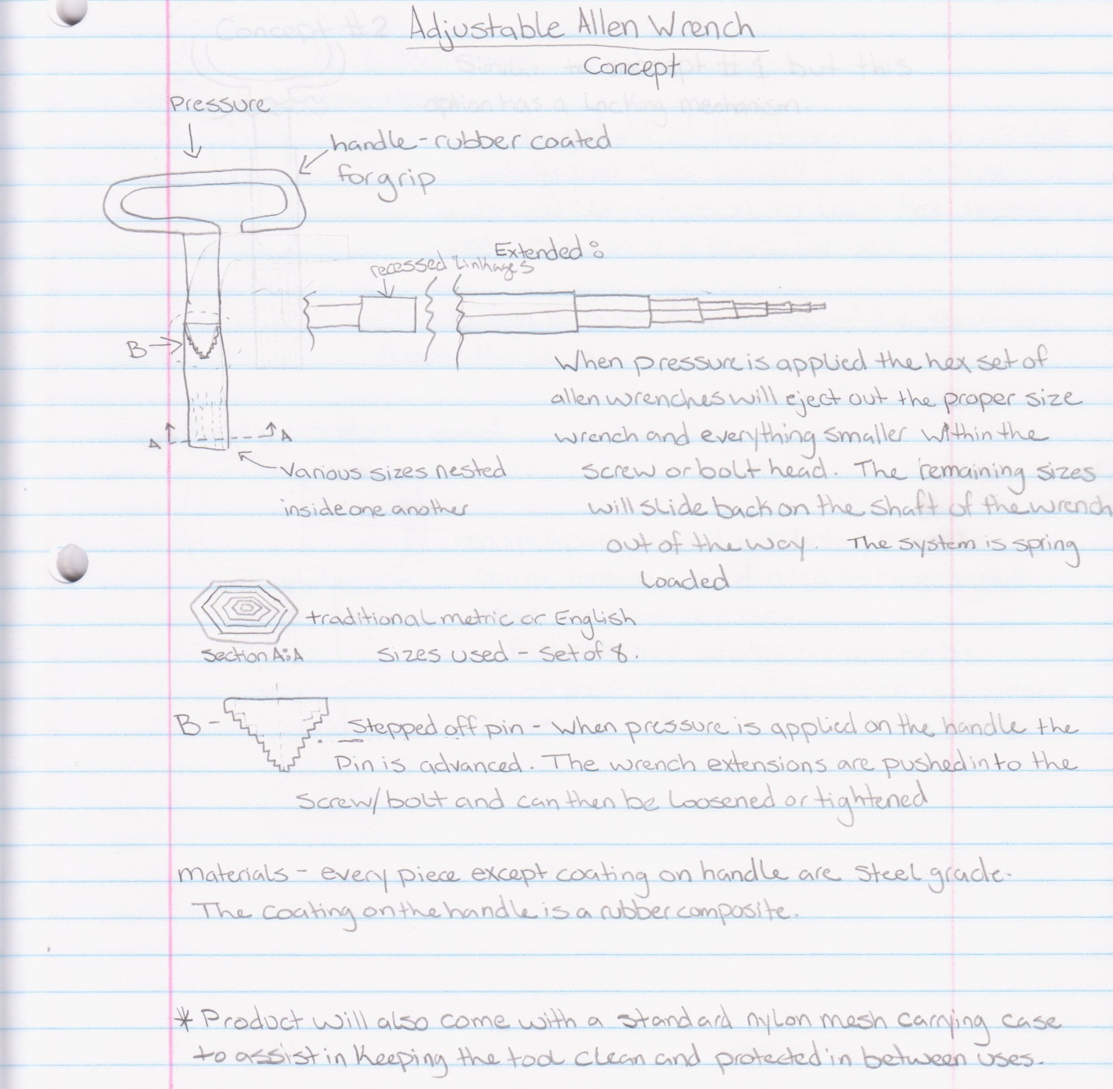
Figure 3: Design A
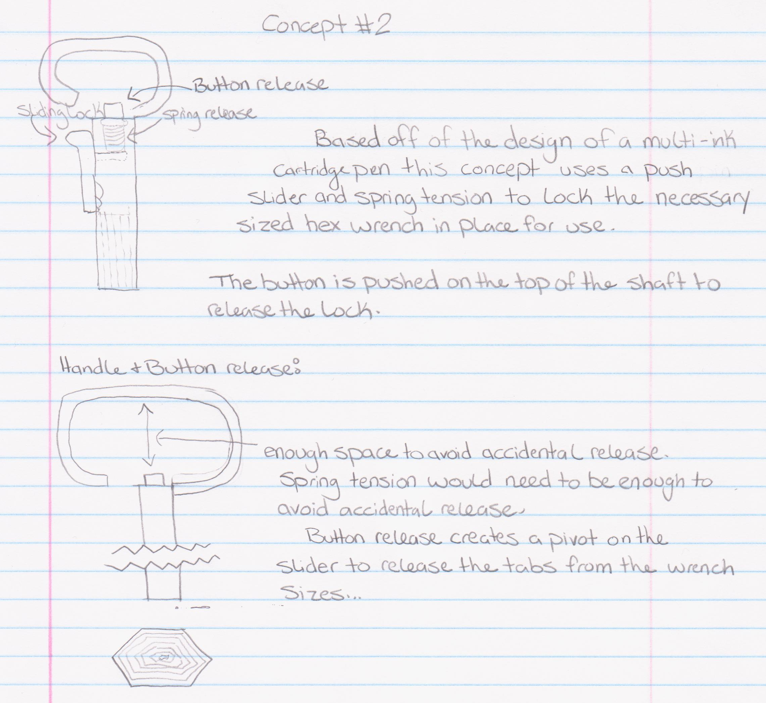
Figure 4: Design B
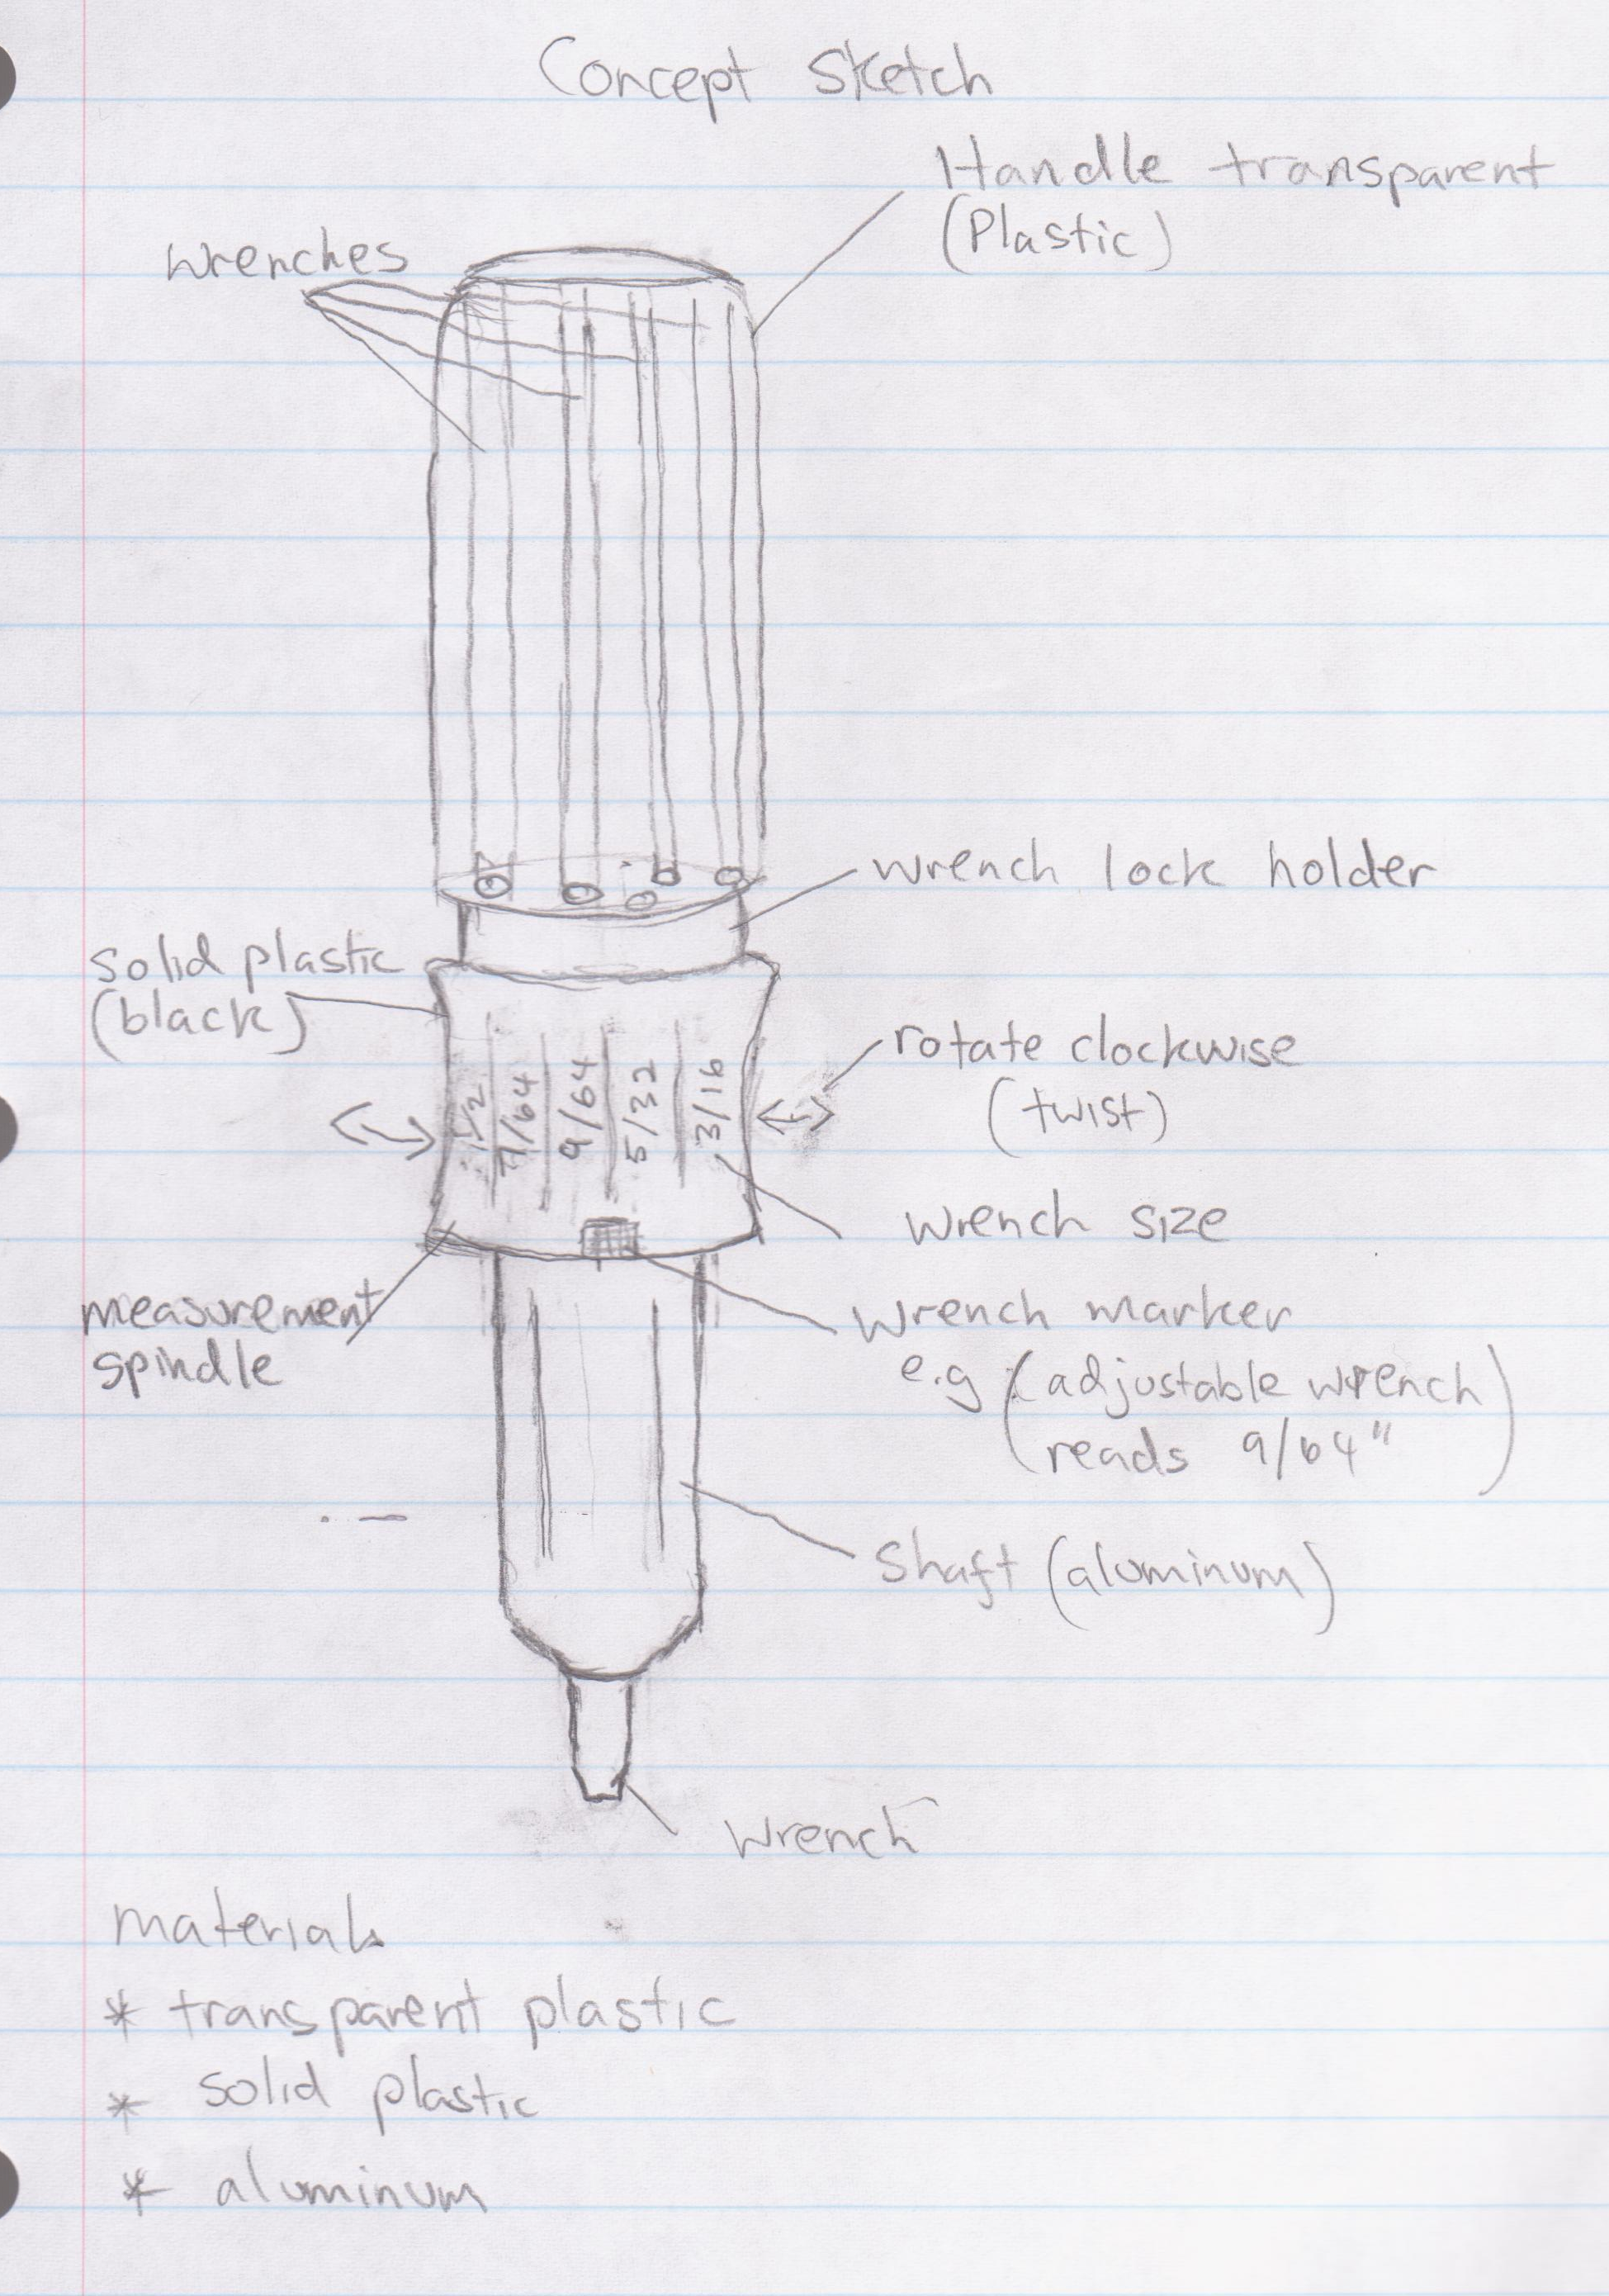
Figure 5: Design C

Figure 6: Design D
Figure 7: Design E

Concept Screening & Scoring Tables
Table 1: Concept Screening Table

Table 2: Concept Scoring Table

Concept Combination Tables
Table 3: Concept Combination Table

Project Tolerances
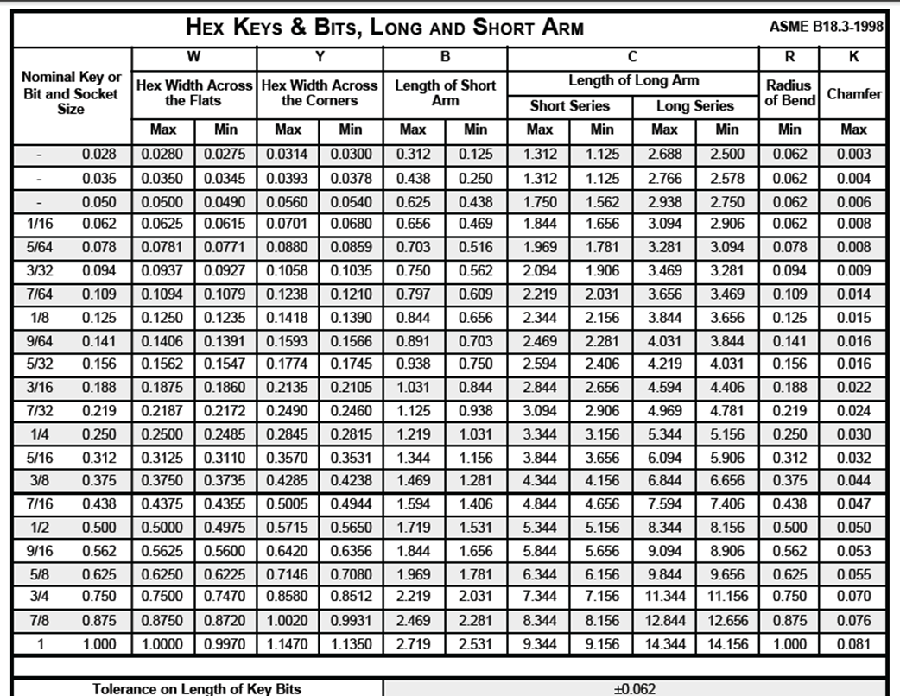

These are the basic specifications met by an average tool set. The First chart provides the Hex, Bit and Socket size, Hex Width Across the Flats of the maximum and minimum size, Hex Width Across the Corners of the maximum and minimum size, Length of Short Arm of the maximum and minimum size, Radius of Bend as minimum and Chamfer as a maximum with a tolerance of +_0.062.
The second chart provides the Torsion Shear Average and Torque Rating of the wrench. The adjustable Allen wrench should meet somewhat the standards of the chart above.

http://www.fastenersuperstore.com/productSheets/SocketsHexKeys.pdf

Project Scope and Exclusions

PROJECT OBJECTIVE

To design an adjustable Allen Wrench using CAD software, FEA Analysis, Rapid Prototyping, Project Submission and Pre Manufacturing of the product.

TECHNICAL REQUIREMENTS
1. Wrench must meet required tolerances of an average wrench tool set.
2. Wrench must be easy for portability
3. Exterior must be shock resistant for Durability

LIMITS AND EXCLUSIONS
- Design should be able to work as a prototype.
- Final Product should be Cost efficient
- Design should have access to following sizes of the basic Allen Wrench provided above
- Easy to use
- 1 year Warranty

Critical Success Factors
One of the major success factors for our product will be its ability to easily, and properly, fit various sizes of hex bolts as well as be able to withstand the torque and other forces needed to loosen/tighten bolts in use. If the adjustable Allen wrench cannot hold up to average wrench use then the product is a failure and will not be able to compete with competitor products. Another critical success factor would be if the product is bought by consumers once the product passes testing. If the tool isn’t bought then the company will fail. If early customers are satisfied with the product word-of-mouth will assist in spreading word about the product and in turn help the customer base grow. Once this version of the product hits the market the data of the sales can be evaluated and customer feedback will be evaluated to assist in determining what future models can be developed.

Interfaces
This product must interface easily with standard metric and English sizes of hex bolts to make the use of the product easy for the customer. The tolerance for the adjustable Allen wrench must fit within the standard tolerances of the bolts for proper use. Another factor in consideration is the fit within the user’s hand. The tool must not be too large or too small in the customer’s hand or use of the product will be more difficult.

Synopsis

Evaluation

Conclusion/Summary

Signature Page

References
http://www.bjg-design.com/designbook/allen1.htm

Appendices

